Report

Laboratory Work 3

Dmitry Ladutsko

August 11, 2022

# 1. Prerequisites

## 1.1. Passwords Index

| Password Group | Login Name | Password |
| --- | --- | --- |
| Operation System | root | “rootadmin” |
|  | oracle | “oracleadmin” |
|  |  |  |
| Oracle System | sys | “sysadmin” |
|  | system | “sysadmin” |
|  |  |  |
| Oracle Users | All DB users | “%PWD%” |
|  |  |  |
|  |  |  |

## 1.2. Folder Paths Index

| Path Group | Path Description | Path |
| --- | --- | --- |
| Operation System | Oracle RDBMS – BIN | /oracle/app/oracle |
|  | Oracle Inventory | /oracle/app/oraInventory |
|  | Oracle Database Storage | /oracle/oradata |
|  | Oracle Install Directory | /oracle/install |
| Oracle | ORACLE_BASE | /oracle/app/oracle |
|  | ORACLE_HOME | $ORACLE_BASE/product/11.2 |
|  |  |  |
| FTP | ftp Incoming Folder | /ftp/incoming |
|  |  |  |
|  |  |  |

**2. Business analysis tasks – Reports**

**2.1. Task 01: Export Geo Location Reference**

**The Main Task is to export Geo Location Reference on Denormalized table.**

**Create Denormalized export table on SB_MBackUp schema.**

**Required points:**

* **Create Denormalized table data using CONNENT_BY**
* **Add Additional Columns to table:\**

**Geo_id types: Branch, ROOT, Leaf**

**Count of childs of Branch or Root, for Leafs this Field you have fill by NULL**

**Full path of Dependencies by Example: ROOT -> BRANCH -> BRANCH -> LEAF**

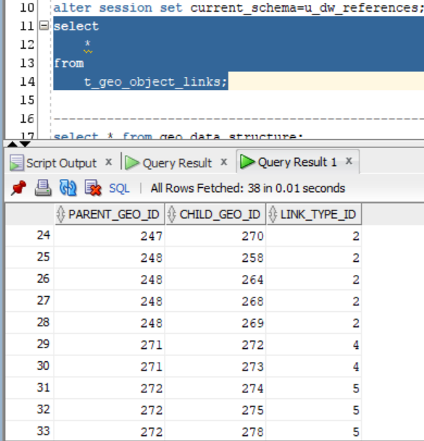

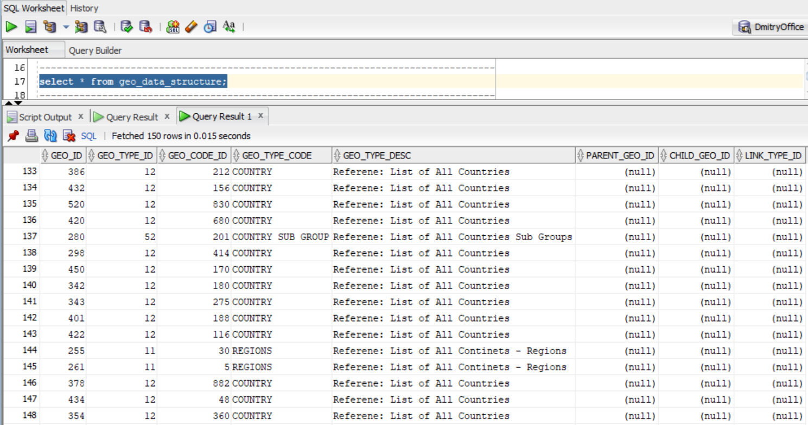

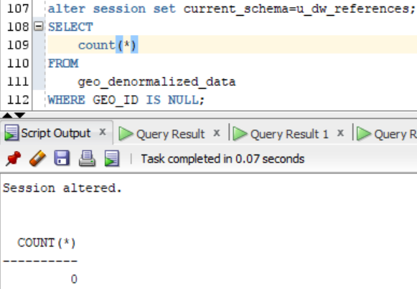

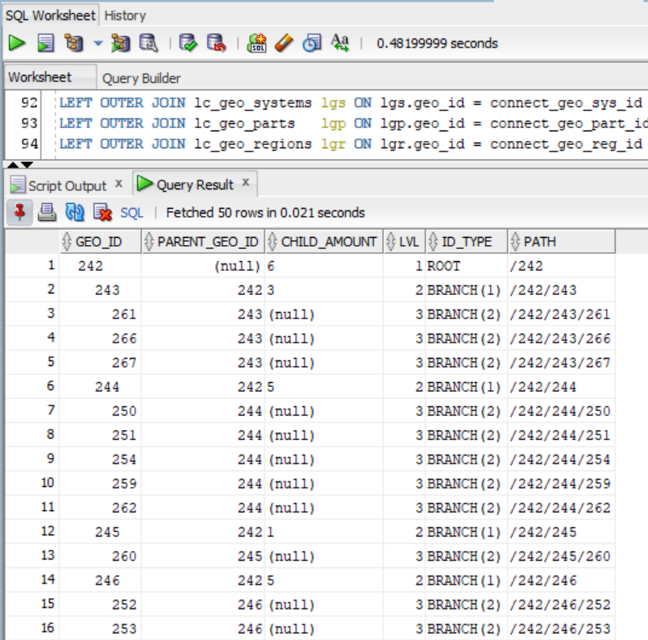

**Task Results:**

**Create required objects:**

* **Create New Schema SB_MBackUp and New Default TableSpace**
* **Put objects script to Git.**

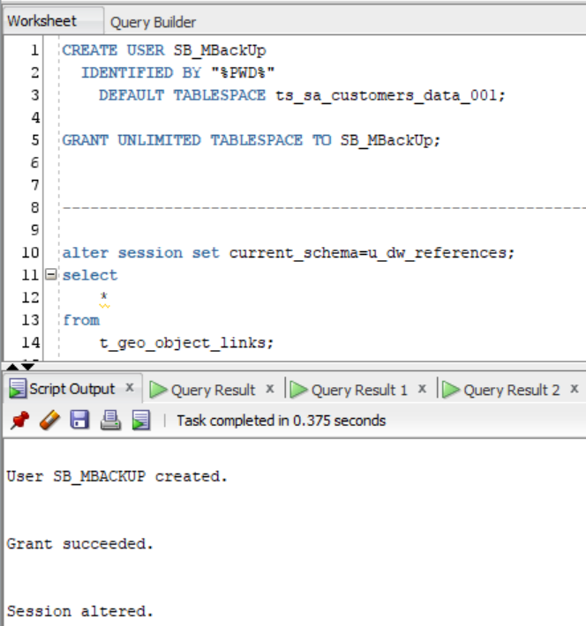

* **Prepare Document with Screenshot of Data on Denormalized table**
* **Prepare load script and put it to GIT**

**2.2. Task 02: Analyze Business hierarchy Reference Analyses**

**The Main Task is to create hierarch analyses of any Dimension, according yours Solution Proposal and DWH Solution Concept from Module 6. Introduction to DWH**

**Required points:**

* **Create Denormalized table data using CONNENT_BY**
* **Use START WITH Clause**
* **Use CONNECT_BY_ROOT to analyses any Branch levels**
* **Analyze Main Root Branch, and 2 Sub Branches**

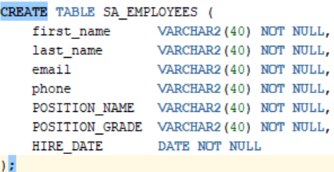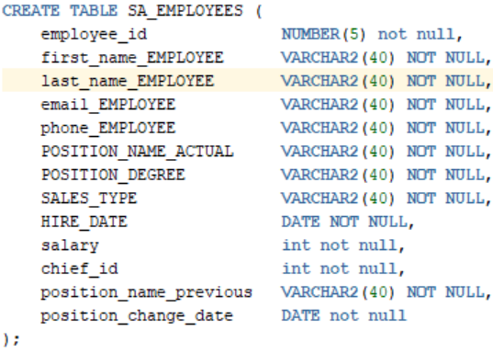

**Here, as you san see, I added more data into sa_employees table (Left - previous version, right - new)**

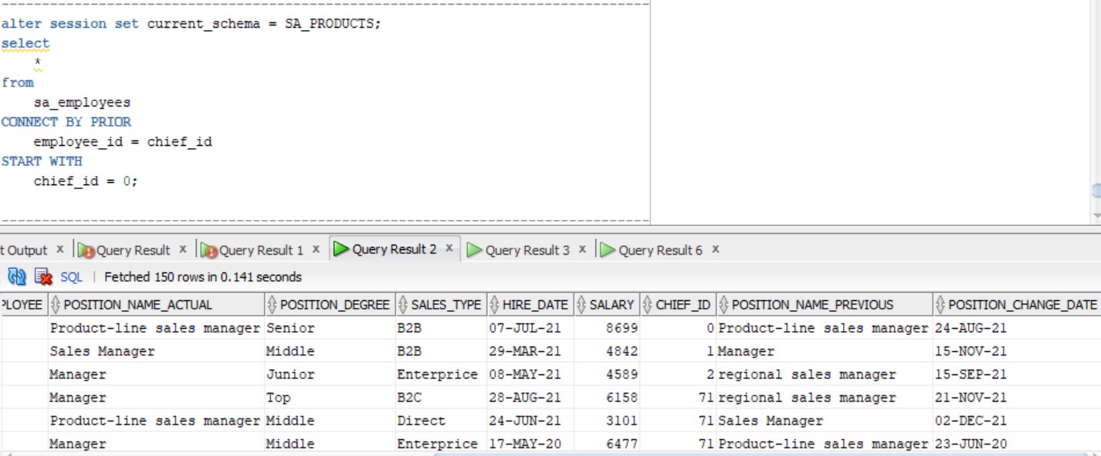

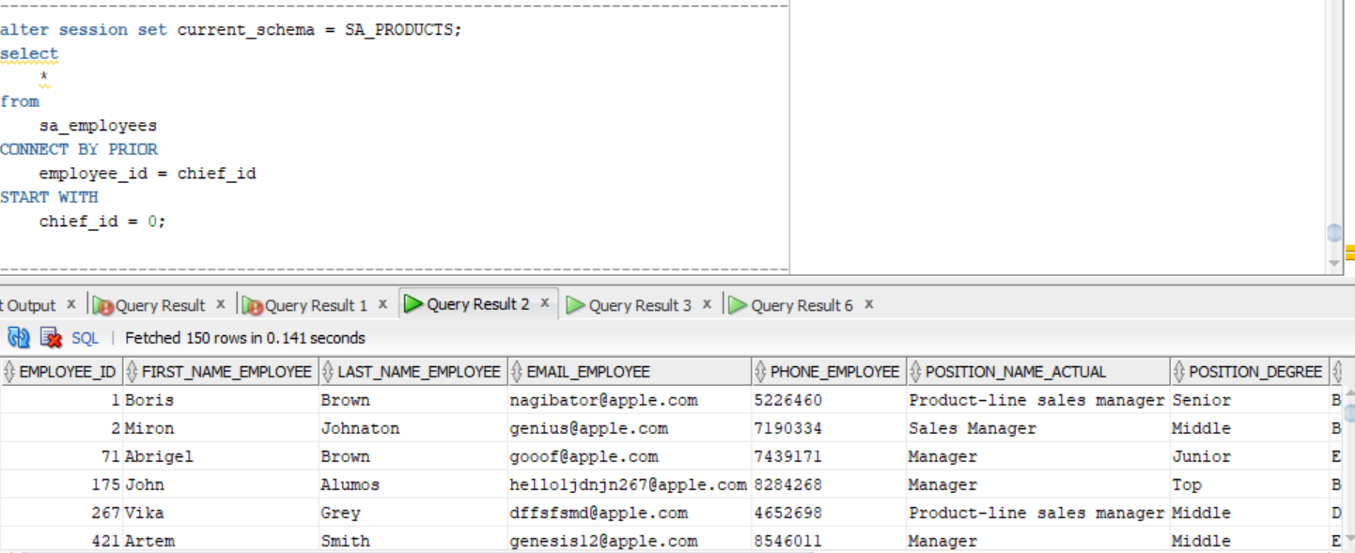

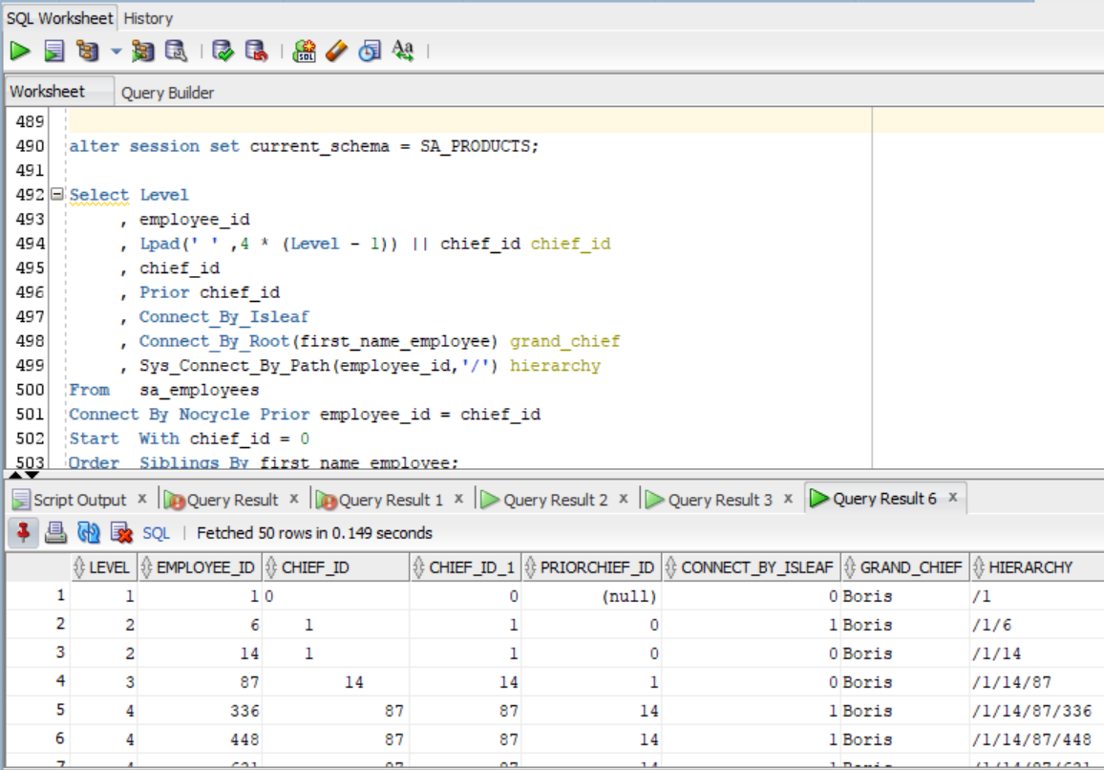

**In the pictures above** you can see how **employees** related with **chiefs**. And who is a chief for every employee, who is a **grand chief** and their 4 - staged **hierarchy**.

**Task Results:**

**Create required objects:**

* **Prepare Document with Screenshot of analyses Data result**
* **Prepare script and put it to GIT**

***Note.*** All scripts stored on GitHub.

**Laboratory work summary:**

**At this lab** we have learned how we can carry out a hierarchy schema using different statements, such as :

* Connect_by
* Connect_by_root

**Specified with** such clauses as **Start With** and **Level** pseudocolumn which shows parent and child rows. **Now we have** much more understanding about hierarchy usage.